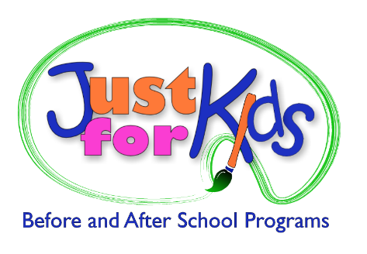

Marketing / Communications / Public Relations Intern

TripleTrack HR Partners, a Williamsville consulting firm, has an opportunity for a part-time (10-15 hours weekly) Marketing / Communications / PR Intern. The internship will provide hands-on experience in a fast paced, small business environment for college course credit.
TripleTrack HR Partners provides outsourced human resources consulting and services for small- and mid-sized companies in Western New York. We have a diverse client base across a variety of industries, for profit and not-for-profit, family owned, etc.
This internship will provide experience in marketing, communications, public relations and large scale projects which may include: developing a strategic marketing plan, creating e-newsletters and other client communication, developing a social media campaign, creating client surveys, create promotional video footage for our website, etc.
Requirements:
- At least a 3rd year college student in good standing
- Preference given to students majoring in business / marketing / communications
- General knowledge of marketing, communications, public relations practices and disciplines
- Excellent written communication skills
- Computer proficiency in Microsoft Office Suite
- Ability to work well independently and as part of a team
- Ability to follow direction, contribute openly, have a flexible, proactive, “can-do” attitude
We are happy to work with students to obtain course credit upon completion of requisite hours.
Please forward your resume with a letter detailing your days and hours of availability and reasons for interest in the internship position to: kryan@tripletrackhrpartners.com.

